CREATE DATABASE w3q1_orders;

USE w3q1_orders;

CREATE TABLE Salesman(

salesman_id int,

sname varchar(50),

city varchar(50),

commission float

);

INSERT INTO

Salesman(salesman_id, sname, city, commission)

VALUES

(5001, 'James Hoog', 'New York', 0.15),

(5002, 'Nail Knite', 'Paris', 0.13),

(5005, 'Pit Alex', 'London', 0.11),

(5006, 'Mc Lyon', 'Paris', 0.14),

(5007, 'Paul Adam', 'Rome', 0.13),

(5003, 'Lauson Hen', 'San Jose', 0.12);

CREATE TABLE Customer(

customer_id int,

cust_name varchar(50),

city varchar(25),

grade int,

salesman_id int

);

INSERT INTO

Customer(customer_id, cust_name, city, grade, salesman_id)

VALUES

(3002, 'Nick Rimando', 'New York', 100, 5001),

(3007, 'Brad Davis', 'New York', 200, 5001),

(3005, 'Graham Zusi', 'California', 200, 5002),

(3008, 'Julian Green', 'London', 300, 5002),

(3004, 'Fabian Johnson', 'Paris', 300, 5006),

(3009, 'Geoff Cameron', 'Berlin', 100, 5003),

(3003, 'Jozy Altidor', 'Moscow', 200, 5007),

(3001, 'Brad Guzan', 'London', 300, 5005);

CREATE TABLE Orders(

ord_no int,

purch_amt double,

ord_date date,

salesman_id int,

customer_id int

);

INSERT INTO

Orders(

ord_no,

purch_amt,

ord_date,

customer_id,

salesman_id

)

VALUES

(70001, 150.5 , '2012-10-05', 3005, 5002),

(70009, 270.65, '2012-09-10', 3001, 5005),

(70002, 65.26, '2012-10-05', 3002, 5001),

(70004, 110.5 , '2012-08-17', 3009, 5003),

(70007, 948.5 , '2012-09-10', 3005, 5002),

(70005, 2400.6 , '2012-07-27', 3007, 5001),

(70008, 5760 , '2012-09-10', 3002, 5001),

(70010, 1983.43, '2012-10-10', 3004, 5006),

(70003, 2480.4 , '2012-10-10', 3009, 5003),

(70012, 250.45, '2012-06-27', 3008, 5002),

(70011, 75.29, '2012-08-17', 3003, 5007),

(70013, 3045.6 , '2012-04-25', 3002, 5001);

/*SELECT

*

FROM

Orders; */

-- 1a , commission > 12%

SELECT

Customer.cust_name AS "Customer Name",

Customer.city,

Salesman.sname AS "Salesman",

Salesman.commission

FROM

Customer

INNER JOIN Salesman ON Customer.salesman_id = Salesman.salesman_id

WHERE

Salesman.commission > .12;

-- 1b

SELECT

Customer.cust_name,

Customer.city,

Orders.ord_no,

Orders.ord_date,

Orders.purch_amt AS "Order Amount"

FROM

Customer

LEFT OUTER JOIN Orders ON Customer.customer_id = Orders.customer_id

order by

Orders.ord_date;

-- 1c

SELECT

Customer.cust_name,

Customer.city,

Orders.ord_no,

Orders.ord_date,

Orders.purch_amt AS "Order Amount",

Salesman.sname,

Salesman.commission

FROM

Customer

LEFT OUTER JOIN Orders ON Customer.customer_id = Orders.customer_id

LEFT OUTER JOIN Salesman ON Salesman.salesman_id = Orders.salesman_id;

-- 1d

SELECT

Customer.cust_name,

Customer.city,

Customer.grade,

Salesman.sname AS "Salesman",

Salesman.city

FROM

Customer

RIGHT OUTER JOIN Salesman ON Salesman.salesman_id = Customer.salesman_id

ORDER BY

Salesman.salesman_id;

-- 1e

SELECT

*

FROM

Salesman

CROSS JOIN Customer

-- WHERE Customer.salesman_id = Salesman.salesman_id

;

-- 1f

SELECT

*

FROM

Salesman

CROSS JOIN Customer

WHERE

Salesman.city = Customer.city;

-- 1g

SELECT

Customer.cust_name,

Customer.city,

Customer.grade,

Salesman.sname AS "Salesman",

Orders.ord_no,

Orders.ord_date,

Orders.purch_amt

FROM

Customer

RIGHT OUTER JOIN Salesman ON Salesman.salesman_id = Customer.salesman_id

LEFT OUTER JOIN Orders ON Orders.customer_id = Customer.customer_id

WHERE

Orders.purch_amt >= 2000

AND Customer.grade IS NOT NULL;

DELETE FROM Orders;

DELETE FROM Customer;

DELETE FROM Salesman;

DROP TABLE Salesman, Customer, Orders;

DROP DATABASE w3q1_orders;

Inputs:

* Salesman table

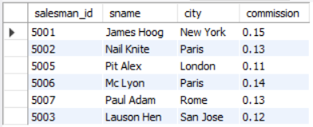

* Customer table

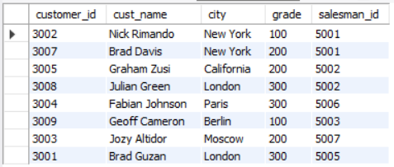

* Orders

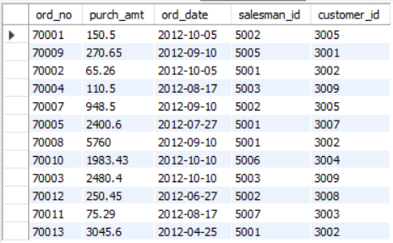

Queries & Outputs:

* SELECT

Customer.cust_name AS "Customer Name",

Customer.city,

Salesman.sname AS "Salesman",

Salesman.commission

FROM

Customer

INNER JOIN Salesman ON Customer.salesman_id = Salesman.salesman_id

WHERE

Salesman.commission > .12;

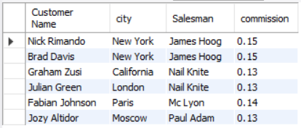

* SELECT

Customer.cust_name,

Customer.city,

Orders.ord_no,

Orders.ord_date,

Orders.purch_amt AS "Order Amount"

FROM

Customer

LEFT OUTER JOIN Orders ON Customer.customer_id = Orders.customer_id

order by

Orders.ord_date;

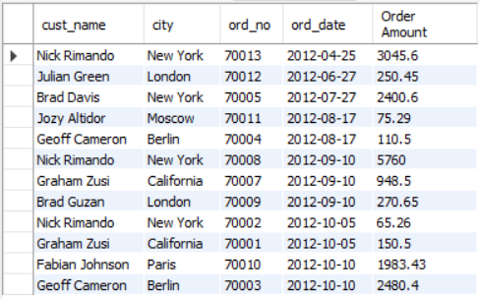

* SELECT

Customer.cust_name,

Customer.city,

Orders.ord_no,

Orders.ord_date,

Orders.purch_amt AS "Order Amount",

Salesman.sname,

Salesman.commission

FROM

Customer

LEFT OUTER JOIN Orders ON Customer.customer_id = Orders.customer_id

LEFT OUTER JOIN Salesman ON Salesman.salesman_id = Orders.salesman_id;

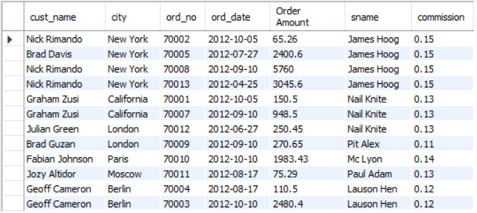

* SELECT

Customer.cust_name,

Customer.city,

Customer.grade,

Salesman.sname AS "Salesman",

Salesman.city

FROM

Customer

RIGHT OUTER JOIN Salesman ON Salesman.salesman_id = Customer.salesman_id

ORDER BY

Salesman.salesman_id;

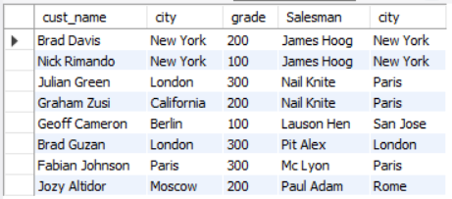

* SELECT *

FROMSalesman

CROSS JOIN Customer

-- WHERE Customer.salesman_id = Salesman.salesman_id;

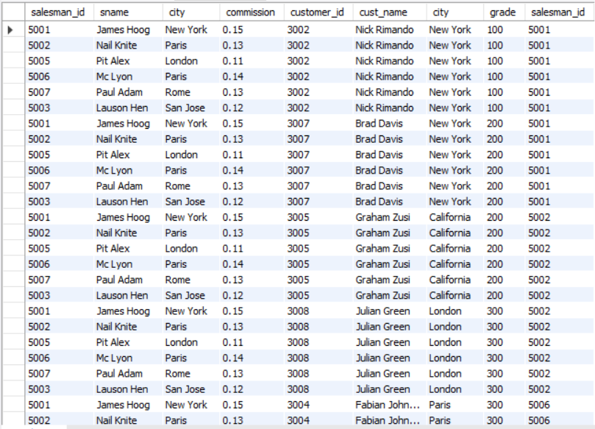

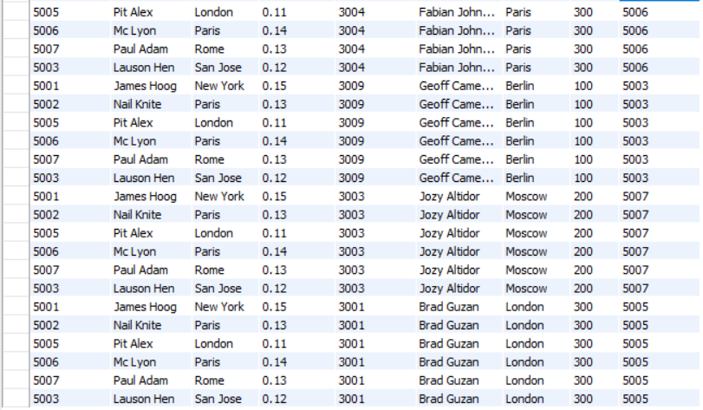

-> SELECT

*

FROM

Salesman

CROSS JOIN Customer

WHERE

Salesman.city = Customer.city;

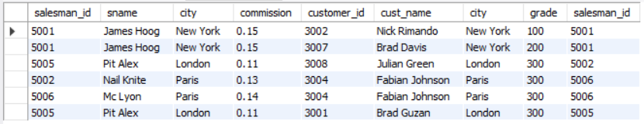

* SELECT

Customer.cust_name,

Customer.city,

Customer.grade,

Salesman.sname AS "Salesman",

Orders.ord_no,

Orders.ord_date,

Orders.purch_amt

FROM

Customer

RIGHT OUTER JOIN Salesman ON Salesman.salesman_id = Customer.salesman_id

LEFT OUTER JOIN Orders ON Orders.customer_id = Customer.customer_id

WHERE

Orders.purch_amt >= 2000

AND Customer.grade IS NOT NULL;

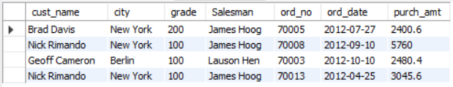

2)

Code:

CREATE DATABASE Empire;

USE Empire;

CREATE TABLE Employee (

employee_id INT PRIMARY KEY,

first_name VARCHAR(25) NOT NULL,

last_name VARCHAR(25) NOT NULL,

email VARCHAR(25) NOT NULL,

phone_number VARCHAR(12) NOT NULL,

hire_date DATE NOT NULL,

job_id VARCHAR(13) NOT NULL,

salary FLOAT(7,2) NOT NULL DEFAULT 0.0,

commission_pct FLOAT(7,2) /*NOT NULL*/ DEFAULT 0,

manager_id INT NOT NULL,

department_id INT NOT NULL -- ,

-- CONSTRAINT manager_id CHECK manager_id IN employee_id

);

INSERT INTO Employee

VALUES

(100, "Steven", "King", "SKING", '515.123.4567', '2003-06-17', 'AD_PRES', 24000.00, 0.00, 0, 90),

(101, "Neena", "Kochhar", "NKOCCHAR", '515.123.4568', '2005-09-21', 'AD_VP', 17000.00, 0.00, 100, 40),

(102, "Lex", "De Haan", "LDEHAAN", '515.123.4569', '2001-01-13', 'AD_VP', 17000.00, 0.00, 100, 90),

(103, "Alexander", "Hunold", "AHUNOLD", '590.423.4567', '2006-01-03', 'IT_PROG', 9000.00, 0.00, 102, 60),

(104, "Bruce", "Ernst", "BERNST", '590.423.4568', '2007-05-21', 'IT_PROG', 6000.00, 0.00, 103, 60),

(105, "David", "Austin", "DAUSTIN", '590.423.4569', '2005-06-25', 'IT_PROG', 4800.00, 0.00, 103, 40),

(106, "Valli", "Pataballa", "VPATABAL", '590.423.4560', '2006-02-05', 'IT_PROG', 4800.00, 0.00, 103, 60),

(107, "Diana", "Lorentz", "DLORENTZ", '590.423.5567', '2007-02-07', 'IT_PROG', 4800.00, 0.00, 103, 60),

(108, "Nancy", "Greenberg", "NGREENBE", '515.124.4569', '2002-08-17', 'FI_MGR', 12008.00, 0.00, 103, 100),

(109, "Daniel", "Faviet", "DFAVIET", '515.124.4169', '2002-08-16', 'FI_ACCOUNT', 9000.00, 0.00, 103, 100),

(110, "John", "Chen", "JCHEN", '515.124.4269', '2005-09-28', 'FI_ACCOUNT', 8200.00, 0.00, 103, 40)

;

-- 2a

SELECT first_name, last_name, department_id

FROM Employee

WHERE employee_id IN (

SELECT employee_id

FROM Employee

WHERE SALARY > 3.7E3

);

-- 2a 2nd way

/* SELECT first_name, last_name, department_id

FROM Employee

WHERE salary > 3700

; /* why only 3700, not 5k? */

-- 2b

SELECT department_id, SUM(salary) AS Total_Salary

FROM Employee

WHERE department_id IN (

SELECT DISTINCT department_id

FROM Employee

-- GROUP BY department_id

-- HAVING COUNT(department_id) >= 1

)

GROUP BY department_id

HAVING COUNT(department_id) >= 1

;

-- 2b 2nd way

/*SELECT department_id, SUM(salary) AS Total_Salary

FROM Employee

GROUP BY department_id

-- HAVING COUNT(department_id) >= 1

; /**/

-- SELECT DISTINCT department_id FROM Employee;

-- 2c but no nested query? , Insert meme chimp asks "where nested query?"

SELECT DISTINCT department_id

FROM Employee

WHERE department_id IN (

SELECT department_id

FROM Employee

)

GROUP BY department_id

HAVING COUNT(department_id) >= 1

;

-- 2d

SELECT first_name, last_name, department_id

FROM Employee

WHERE salary > (

SELECT AVG(salary)

FROM Employee

);

-- 2e

SELECT first_name, last_name, salary, department_id

FROM Employee

WHERE salary > (

SELECT MAX(salary)

FROM Employee

WHERE department_id = 40

);

DELETE FROM Employee;

DROP TABLE Employee;

DROP DATABASE Empire;

Inputs:

* Employee Table

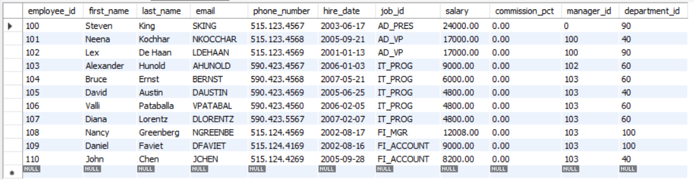

Queries & Outputs:

* SELECT first_name, last_name, department_id

FROM Employee

WHERE employee_id IN (

SELECT employee_id

FROM Employee

WHERE SALARY > 3.7E3

);

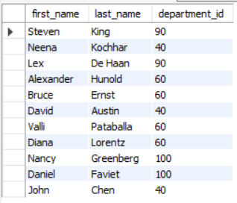

* SELECT department_id, SUM(salary) AS Total_Salary

FROM Employee

WHERE department_id IN (

SELECT DISTINCT department_id

FROM Employee

-- GROUP BY department_id

-- HAVING COUNT(department_id) >= 1

)

GROUP BY department_id

HAVING COUNT(department_id) >= 1

;

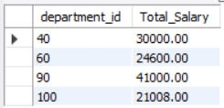

* SELECT DISTINCT department_id

FROM Employee

WHERE department_id IN (

SELECT department_id

FROM Employee

)

GROUP BY department_id

HAVING COUNT(department_id) >= 1

;

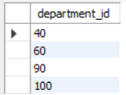

SELECT first_name, last_name, department_id

FROM Employee

WHERE salary > (

SELECT AVG(salary)

FROM Employee

)

ORDER BY salary DESC;

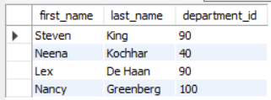

* SELECT first_name, last_name, salary, department_id

FROM Employee

WHERE salary > (

SELECT MAX(salary)

FROM Employee

WHERE department_id = 40

);

